

**SOFT255SL Software Engineering For The Internet Using Java**

**Project Report**

**University library management System**

**Group Name: Concept crew**

**Group Leader: T.H.P.P. MADHUSANKA**

**Group Number: Team 95**

Members:

|  |  |  |
| --- | --- | --- |
| ID | Name | Degree Program (SE/CN/CS) |
| 10707264 | T.H.P.P. MADHUSANKA | SE |
| 10707156 | K.D.H.M. DAHANAYAKE | SE |
| 10707346 | R.M.H.K. RATHNAYAKA | SE |
| 10707228 | B.L.D. JAYASIRI | SE |
| 10707219 | H.S. GAYATHRIKA | SE |
| 10677966 | D.M.B.C. DISSANAYAKE | SE |

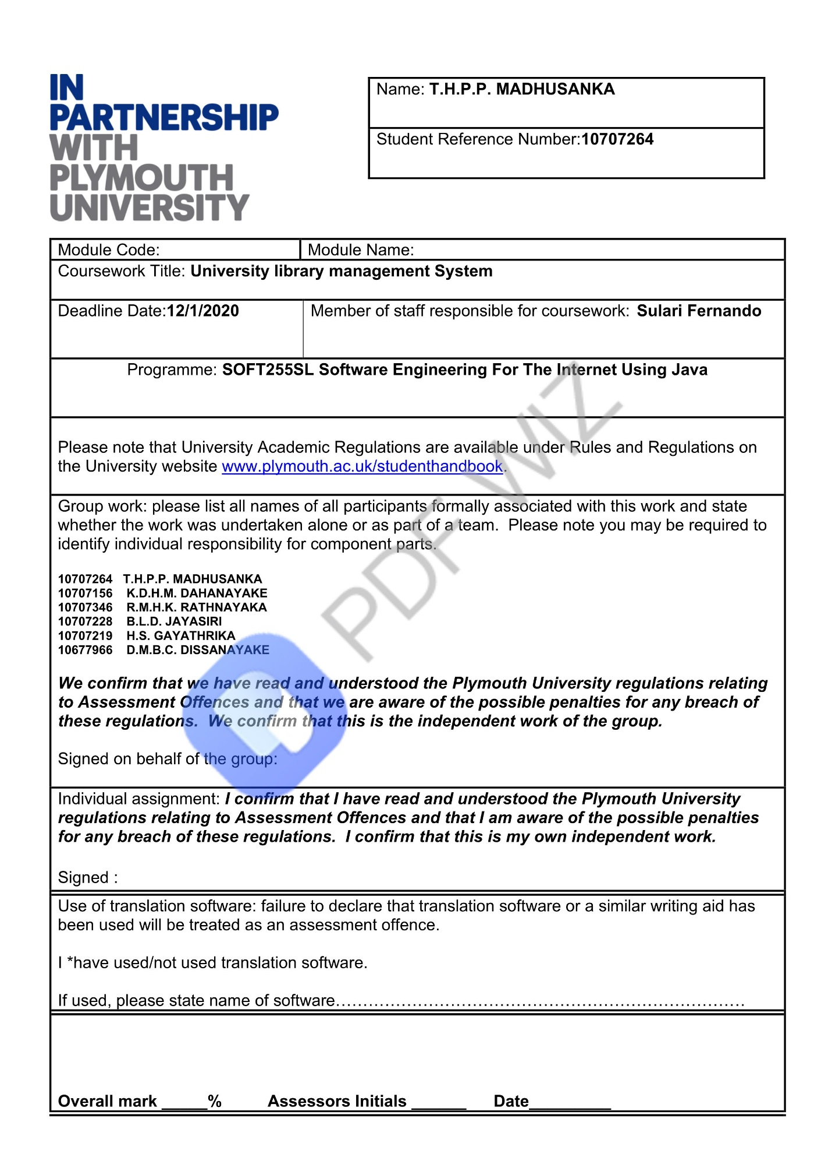

**Introduction to the Scenario**

Library Management System is used to handle daily operations in a library area. Due to the number of books and other library items in a library, the manual management systems doesn't work properly.

Because of the records that kept by librarian may be duplicate or missing. To be more functional this system needs to perform adding, updating, deleting, borrow/return, functionalities are essential.

**Team Members workload**

**10707264 T.H.P.P. MADHUSANKA (**Project plane and all diagrams design

and UI design**)-** **Login page /sing up page/start page/forget page and log out and exit coding**

**10707346 R.M.H.K. RATHNAYAKA (**UI design, database design**)- Home page coding**

**10677966 D.M.B.C. DISSANAYAKE (**Interface coding**)-Add book /Add magazine/Book details/Magazine details**

**10707156 K.D.H.M. DAHANAYAKE (**Interface coding**)- Issued items/ Return items/statices**

**10707228 B.L.D. JAYASIRI (**Interface coding**)- Add students/Add lectures/student details/lecture details**

**10707219 H.S. GAYATHRIKA (**Interface coding)**-Add cd,dvd/Add papers/cd,dvd details/papers details**

**ER DIAGRAM FOR LIBRARY MANAGEMENT SYSTEM**

Authentication

login

Issue/return

Staff

maintains

Library Items

request

Publish by

by

Members

**USE CASE DIAGRAM FOR THE LIBRARY MANAGEMENT SYSTEM**

publisher

Staff(librarian)

Members

**CLASS DIAGRAMS FOR LIBRARY MANAGEMENT SYSTEM**

**Library management system**

User name

Password

Register ()

Login ()

Log out ()

**Members**

User Id

Name

Phone No

Address

Batch

Course

E mail

Request to Search Items ()

Request to membership ()

Barrow items ()

Return items ()

**Library items**

Items Id

Items title

Price

Author

Language

Item name

pages

Edition

**Staff**

Staff Id

Name

Issue items ()

Return items ()

Add library items ()

Add members ()

Maintains publisher details()

**Publisher Details**

Publisher Name

Publisher Id

Publisher phone No

**Start page**

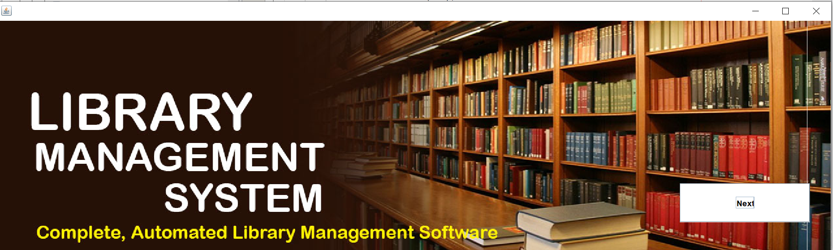

**Login page**

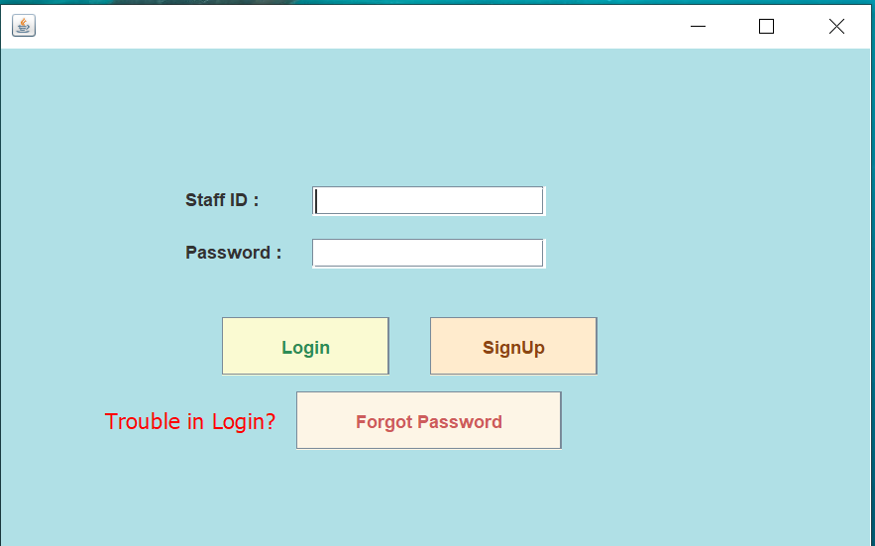

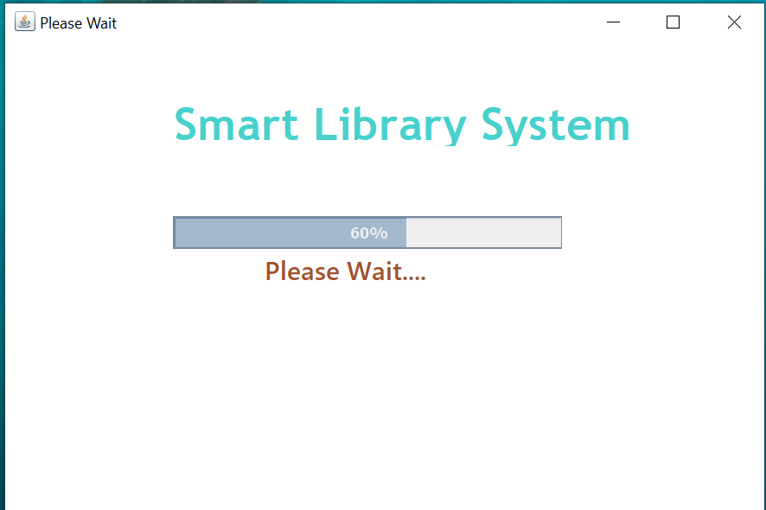

**Sign up page**

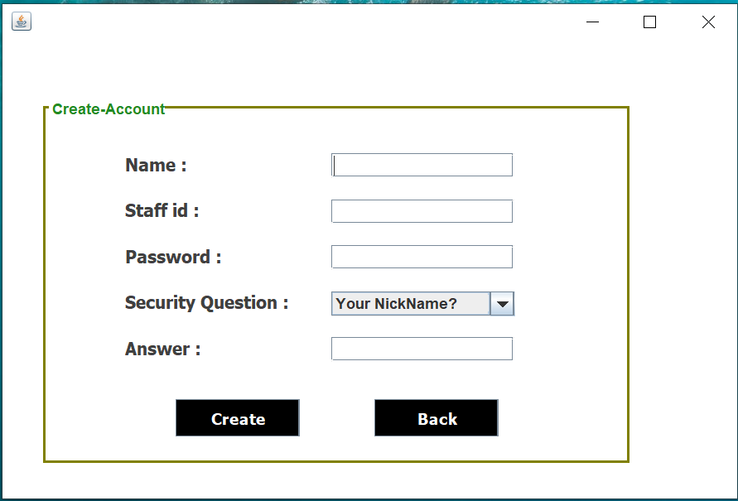

**Forget password**

**Home page**

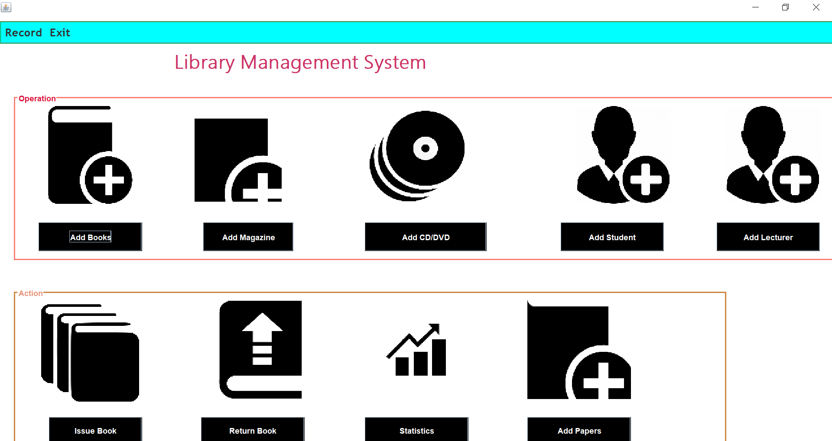

**Add book**

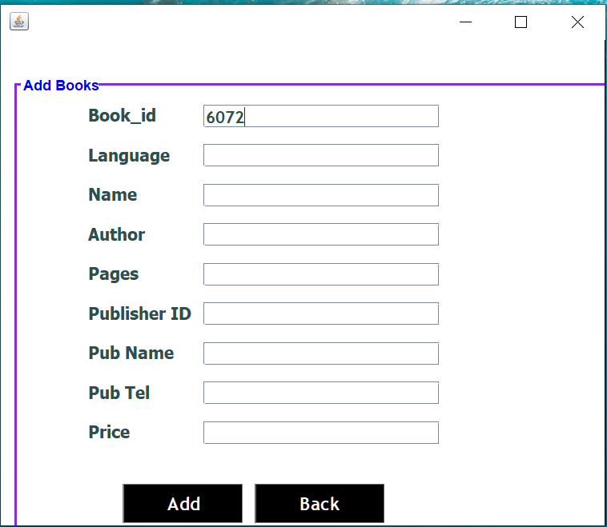

**Add Magazine**

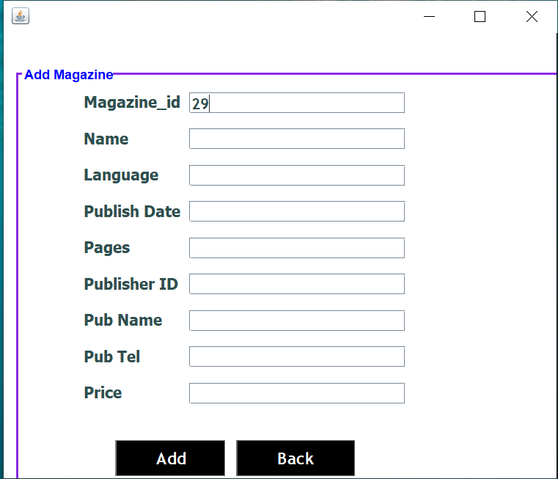

**Add cd/dvd**

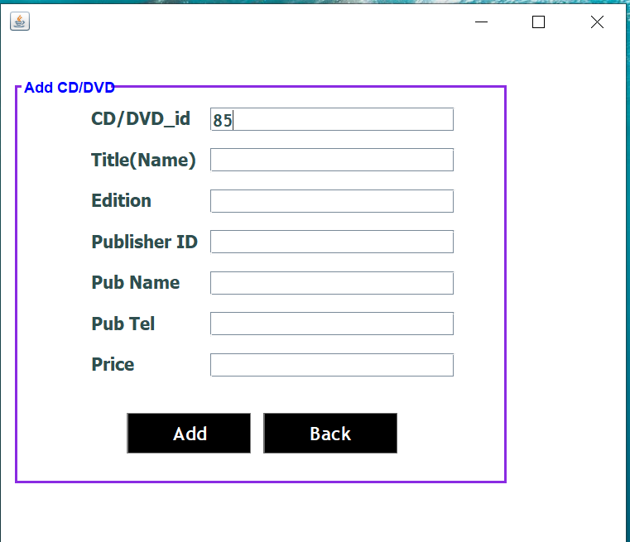

**Add papers**

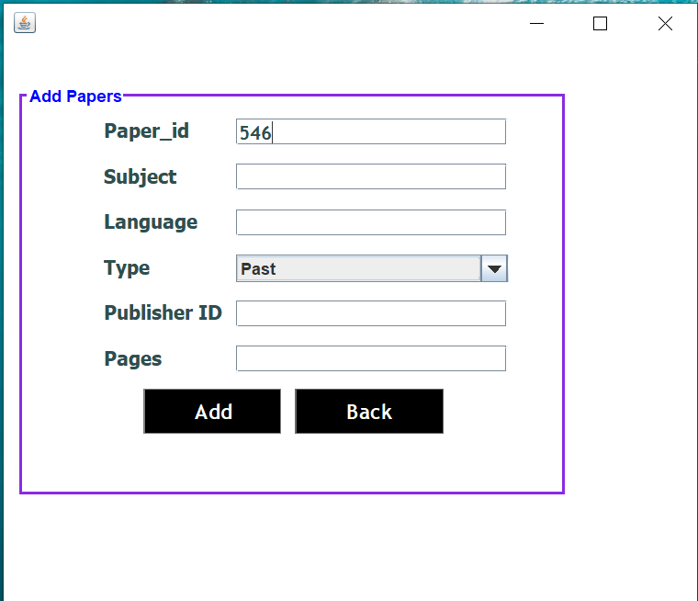

**Book details/cd details**

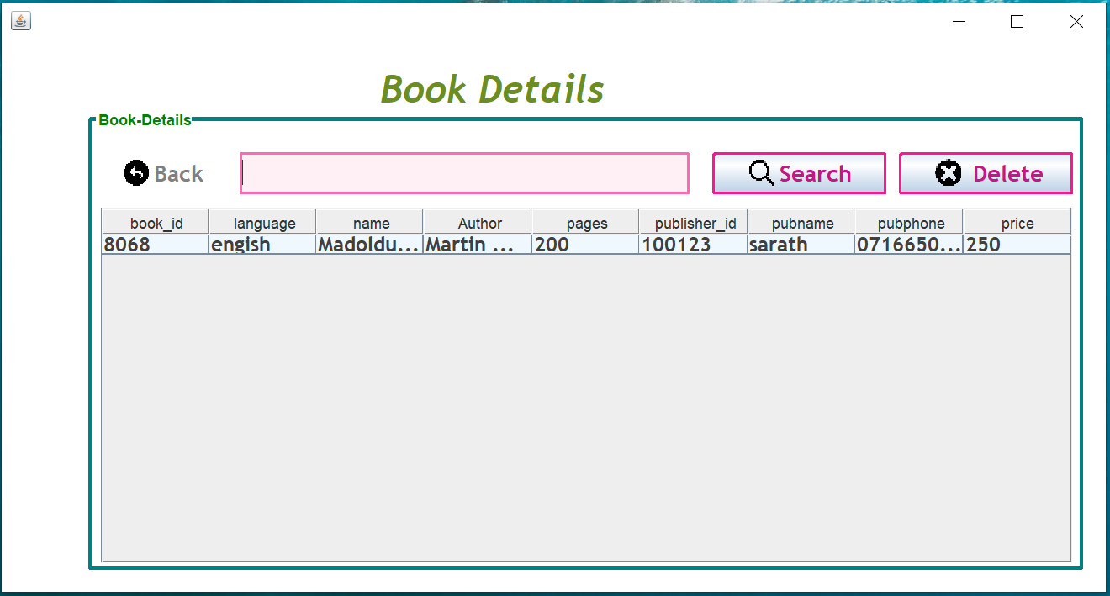

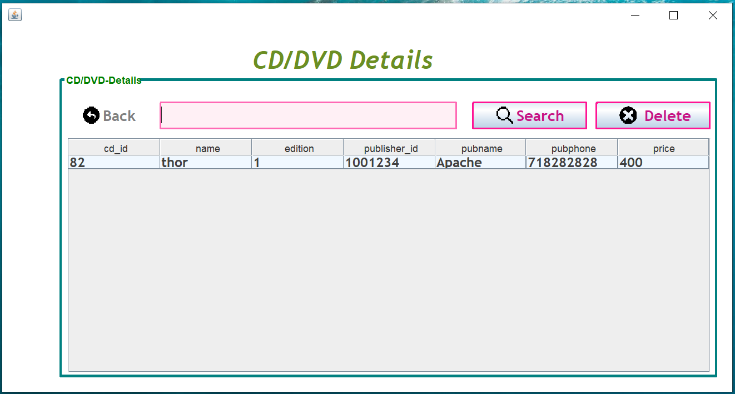

**Magazine details/papers details**

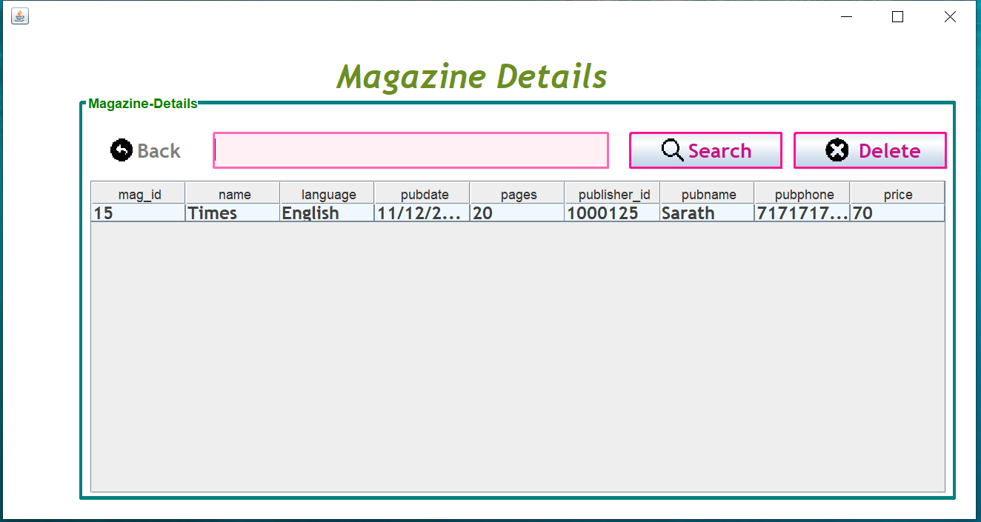

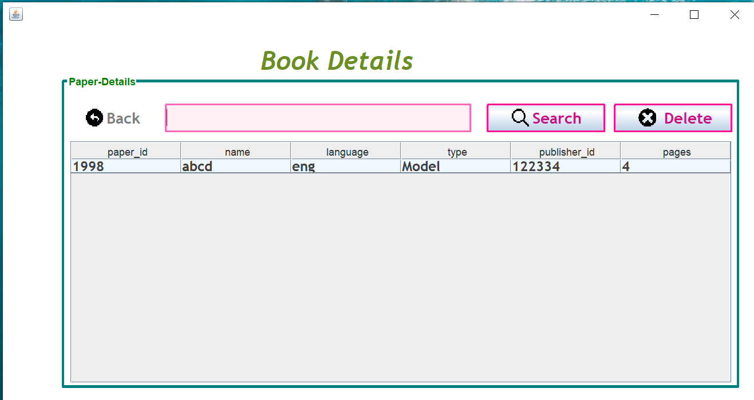

**Add students/Add lectures**

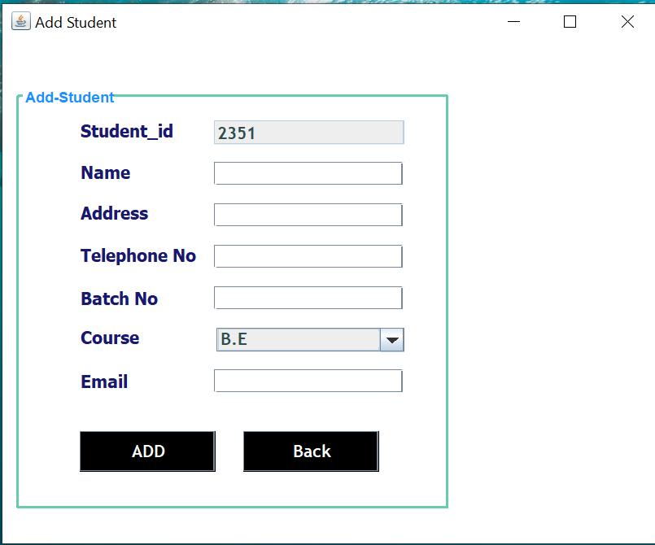

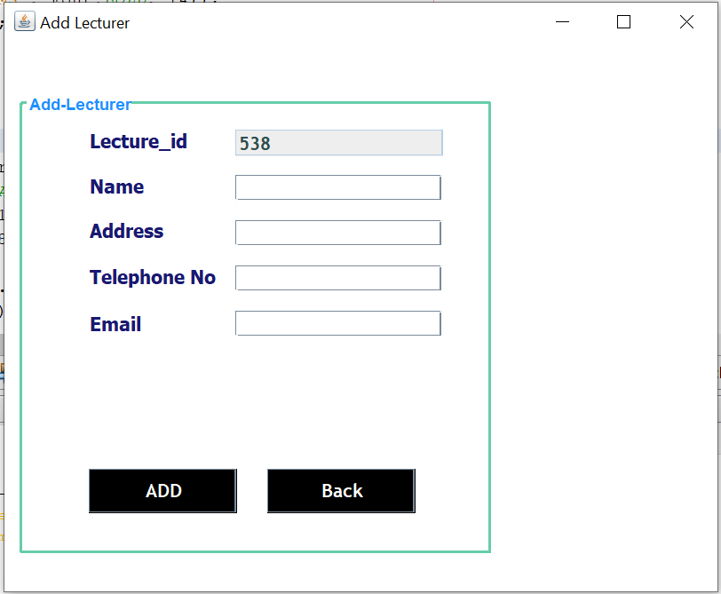

**Students details/lecture details**

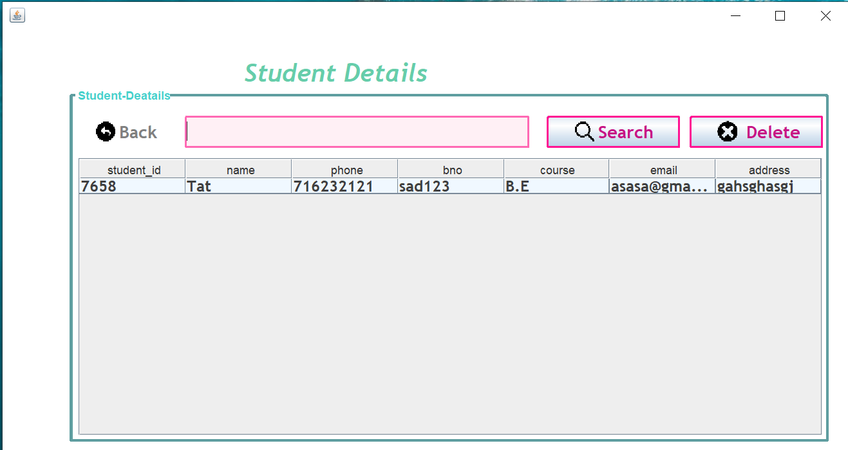

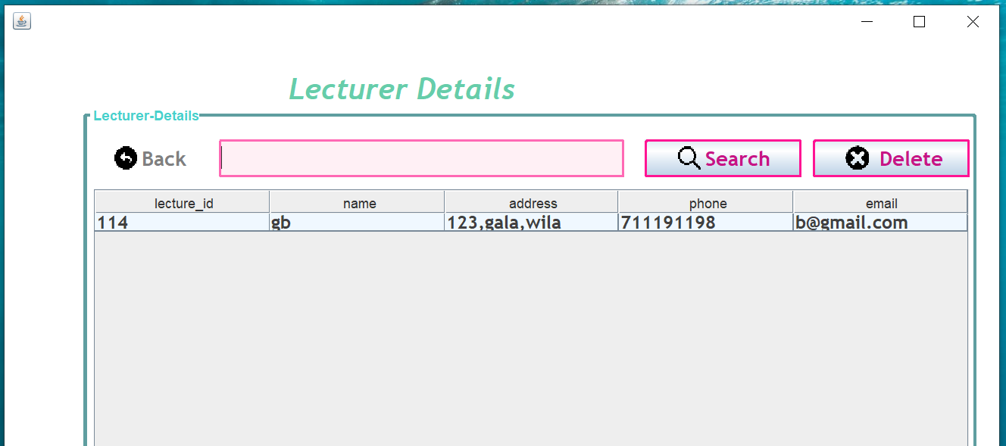

**Issue page**

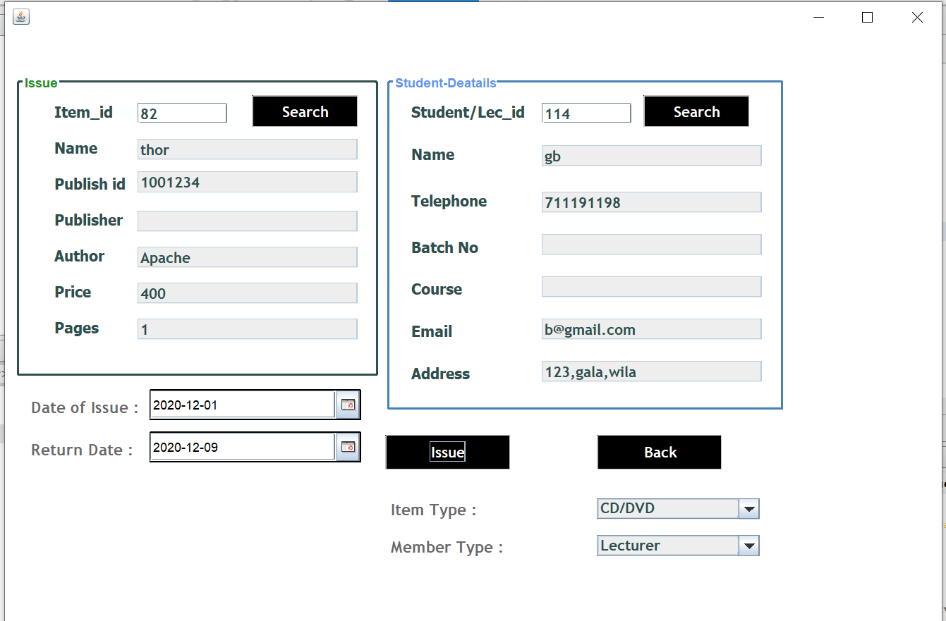

**Return**

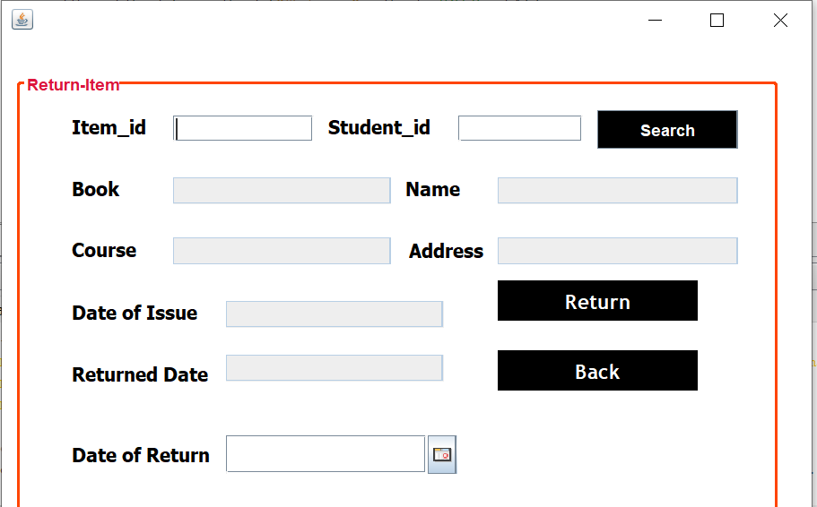

**Statics**

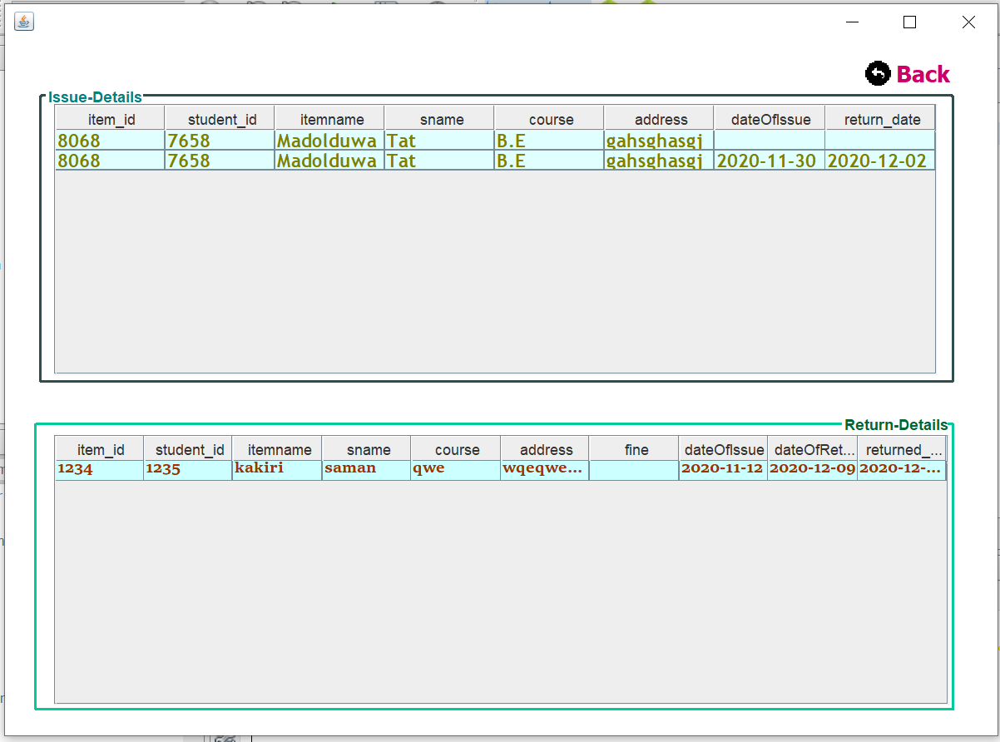

**Log out and exit**

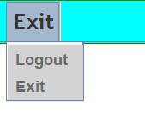

**END THE REPORT**